Jinku Jung
IT 2351 Enterprise Data System
Assignment 11—Jinku Jung

Contents
1.) Reviewing Procedures and Input Variables 2
2. Create an Update Notice Trigger 3
3. Using UPDATE to change a table row entry. 4
4. Check to see if Event Scheduler is ON: 5
5. Create a daily event to clear the Audit Table 6
6. Use SHOW EVENTS to show active events in the database you're running 7

Jinku Jung
IT 2351
4/25/2026

Assignment 11

1.) Reviewing Procedures and Input Variables
Question: “Create an audit table for the courses table in the courses database. You should create matching fields to store values we will pull from each of the four fields as well as fields to capture what types of changes are made and when.”

Answer:
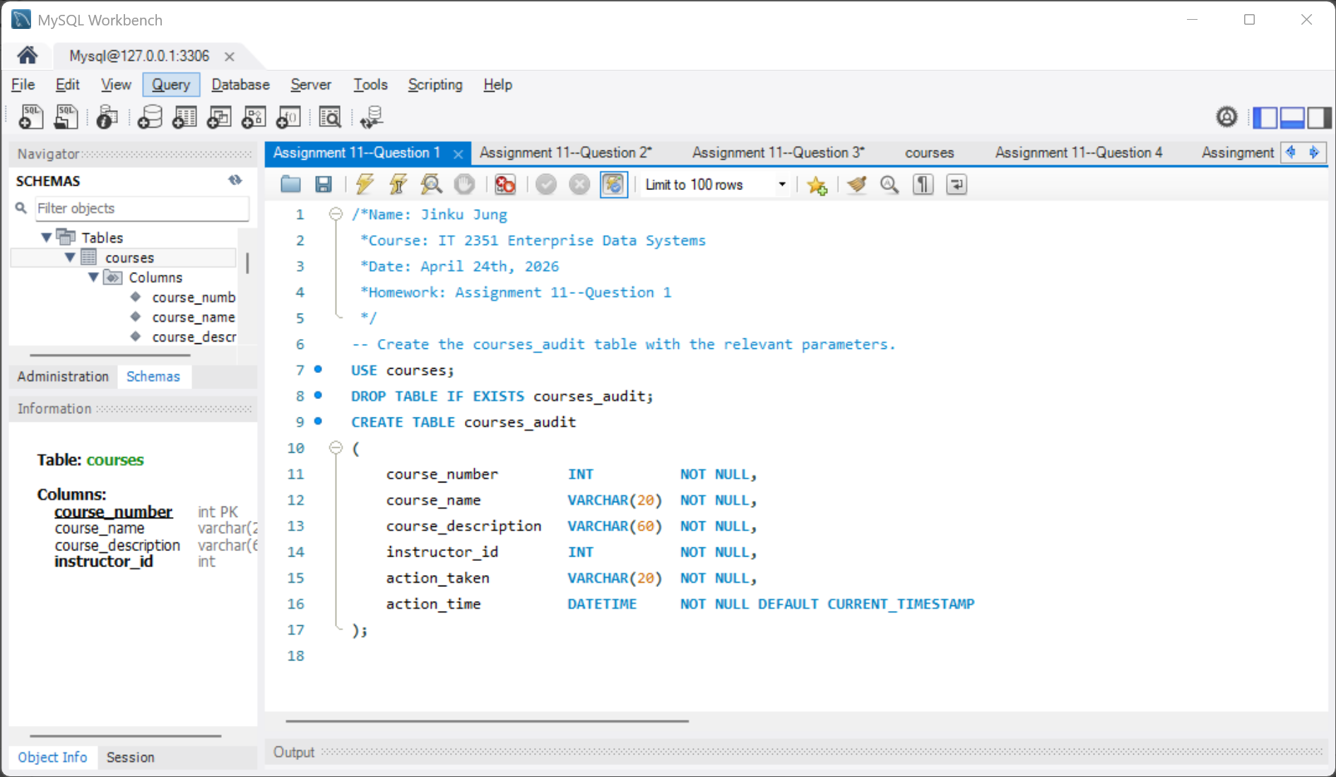

2. Create an Update Notice Trigger
Question: “Create a trigger for this table that will be called whenever an update is made on the table. When this occurs, we want to store the change in the audit table with 2 rows. One that shows what the row in the courses table was changed: a.) FROM and one that shows what the row was changed AND b.) TO. This trigger should also appropriately populate the type of change field and the date field.”

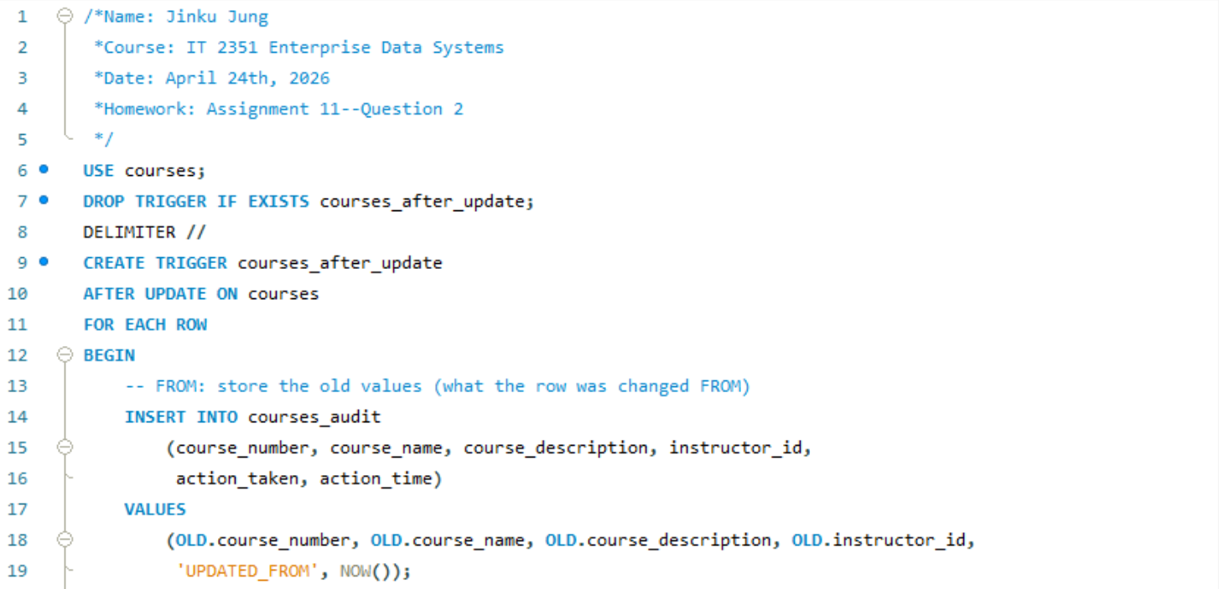
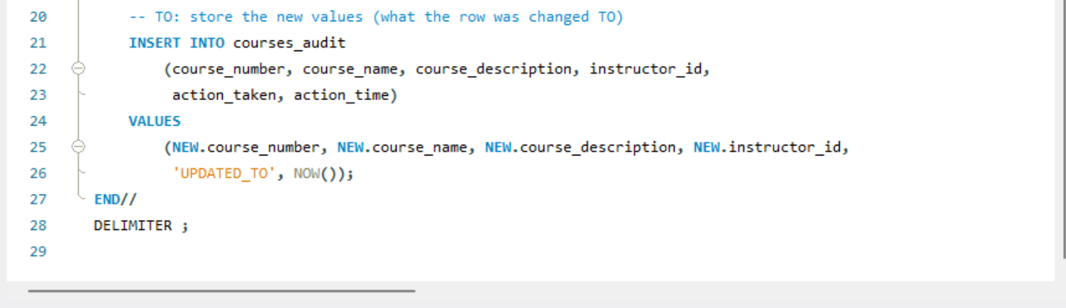

3. Using UPDATE to change a table row entry.
Question: “Use an update statement to change one of the rows in the courses table. Change the description to something new. Then, see your audit table to see the new rows that have been created.”

Answer:
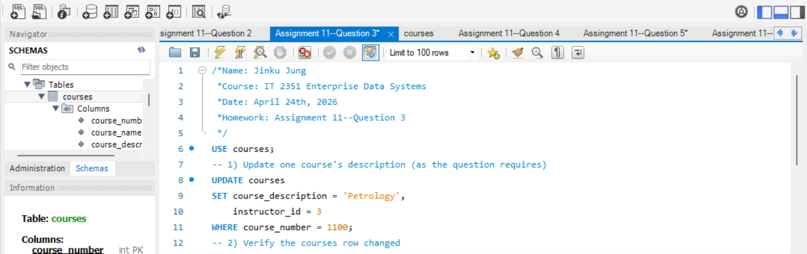
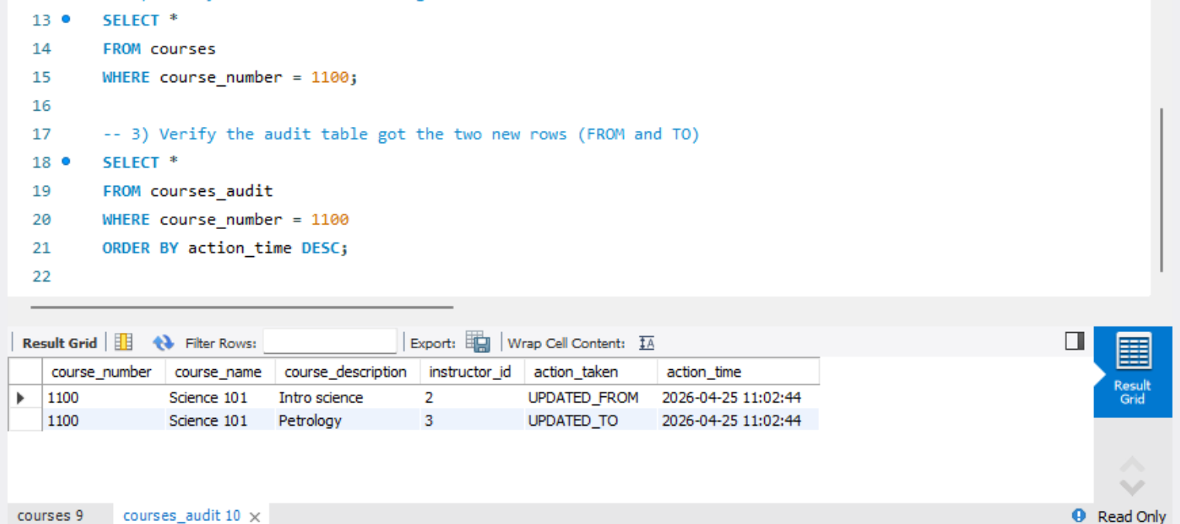

4. Check to see if Event Scheduler is ON:
Question: “Use the appropriate command to ensure that the event scheduler is turned on. If it isn’t already, turn it on:”
Answer:
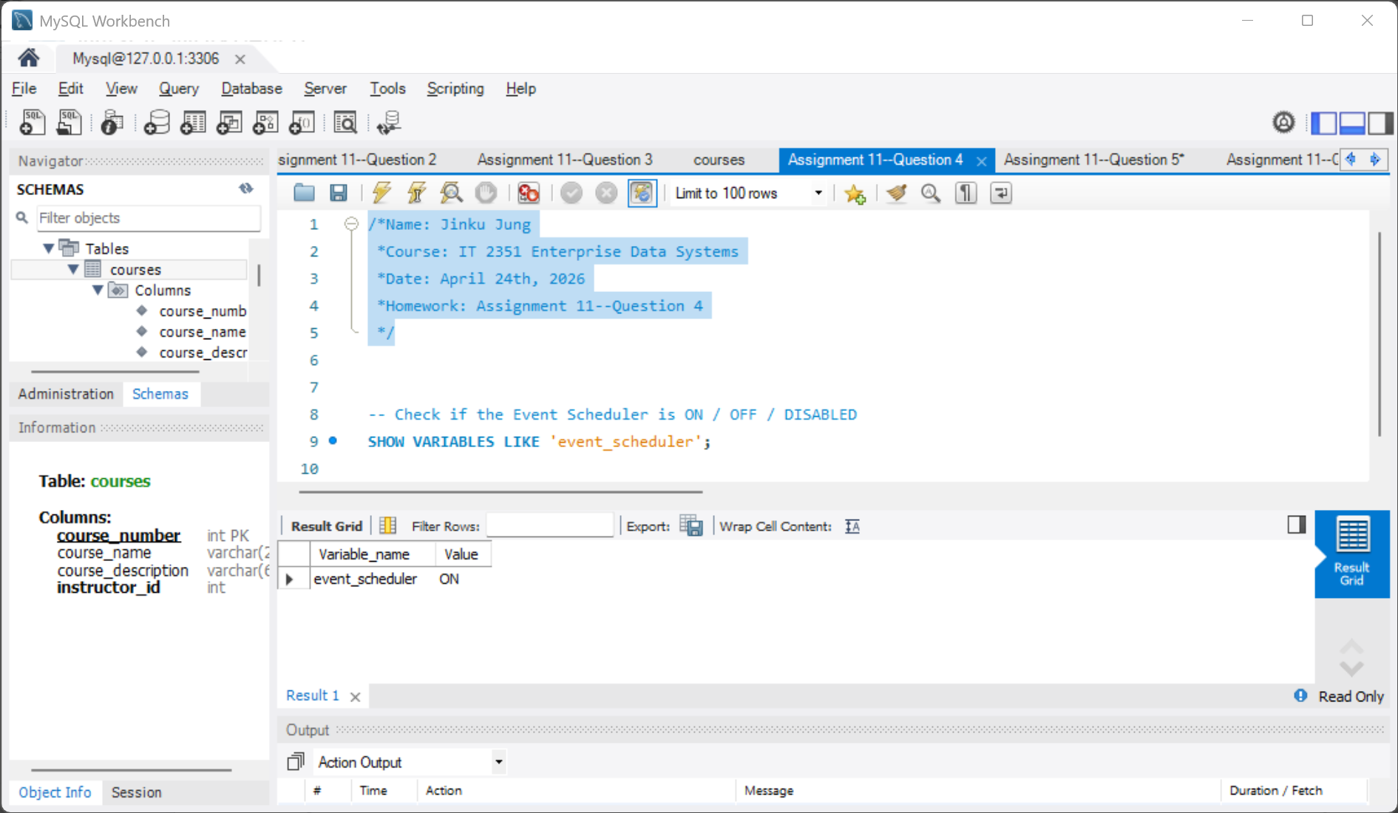

5. Create a daily event to clear the Audit Table
Question: “Create an event that will run every day at 9 pm to clear out the audit table.”

Answer:
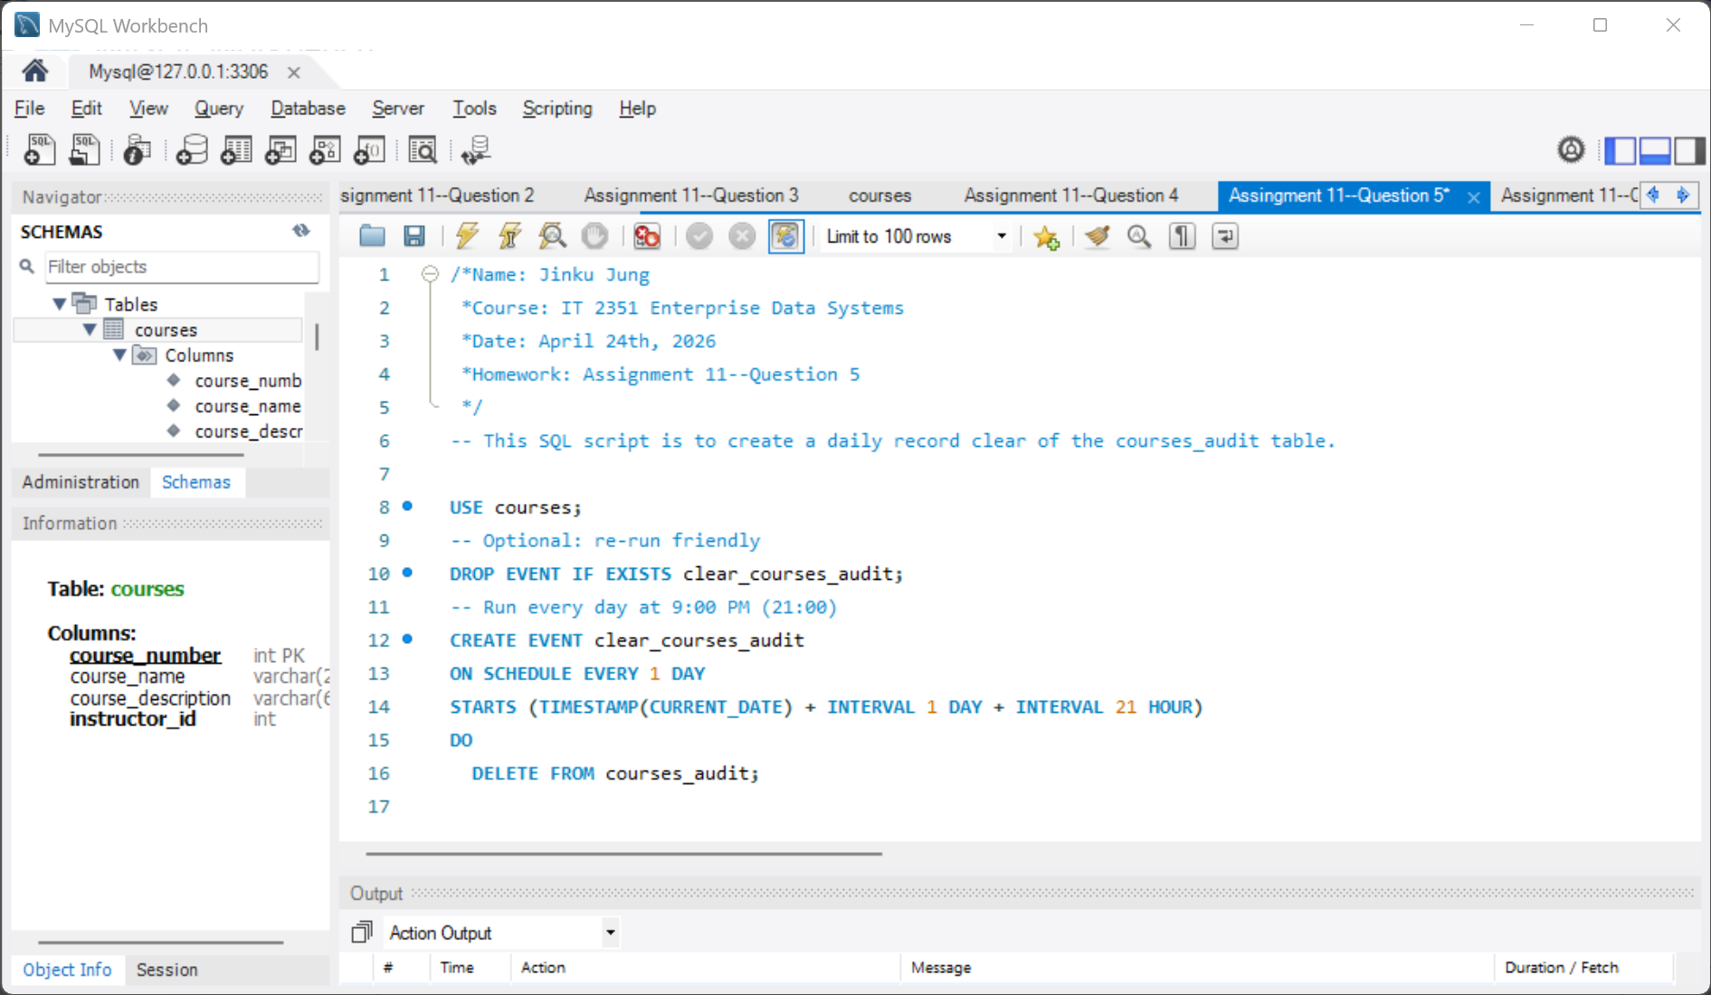

6. Use SHOW EVENTS to show active events in the database you're running
Question: “Use the show events command to show the active events in the database.”
Answer:
